Project Proposal

AI Driving Monitoring System Using

rPPG Blood Oxygen Level, and Pulse Detection

Supervisor:

Professor Chau Yun Hsu

Member:

Chang Shan-Wei, Chen Bo-Shen

Introduction
Road safety remains a pressing global issue, with driver fatigue, distraction, and impairment being major contributors to accidents. While current driver monitoring systems—such as those tracking steering behavior or eye movement—offer useful data, they often fall short in assessing the driver's full physiological and emotional state. A study from Sung et al. (2005), shows the fatigue feeling was highest in the low rate (18%) oxygen condition, while in the high rate (30%), it decreased to a certain extent. The feeling of sleepiness also showed the tendency to decrease somewhat in the case of the driving time having passed over 1h in the high-rate conditions. Our research will aim to detect when low-rate oxygen condition occurs from the drivers and warn the driver throughout application.
Recent advances in artificial intelligence, specifically remote photoplethysmography (rPPG), allow for non-contact monitoring using standard RGB cameras. However, traditional Convolutional Neural Networks (CNNs) struggle to capture long-range temporal dependencies necessary for accurate heart rate variability analysis. To address this, this research proposes a novel Quantum-Inspired Physiological Vision Transformer (Qi-PhysFormer) architecture. We will implement Quantum-Inspired Self-Attention (QiSA) mechanisms on classical hardware to improve signal-to-noise distinction in challenging lighting conditions.
Although existing systems provide some behavioral insights, few offer truly non-invasive, multi-modal monitoring capable of detecting a driver's readiness to drive in complex environments. Our approach aims to close this gap by developing a camera-based system that integrates diverse biological cues to enable earlier and more reliable interventions.

Problem Statement
This project identifies the following key problems when driver has subpar conditions while driving:
  - Current driver monitoring systems often do not account for varying driving conditions and contexts (e.g., urban vs. rural, day vs. night). Research is needed to develop adaptive algorithms that can modify monitoring parameters based on environmental factors and driving scenarios to enhance accuracy and reliability.
  - While there has been progress in using rPPG and computer vision for physiological monitoring, there is limited research on effectively integrating multiple physiological signals (e.g., heart rate, oxygen saturation, facial expressions) in real-time. Understanding how these signals interact and contribute to a comprehensive assessment of driver readiness remains an open area for exploration.
  - Most studies focus on short-term monitoring and data collection. There is a gap in longitudinal research that examines how driver fatigue, distraction, and impairment evolve over time and how physiological signals correlate with these changes. This could lead to more effective predictive models for driver readiness.
  - The implementation of non-invasive monitoring systems raises questions about user acceptance and privacy. Research is needed to explore drivers' perceptions of such technologies, ethical implications, and how to design systems that respect privacy while ensuring safety.

Project Objectives
To address the above problem, the project would develop proof of concept system that uses various types of cameras with AI algorithms for blood oxygen level prediction and heartbeat detection. The following are the primary objectives:
  - Implement a video camera and deep learning system which are used to monitor driver physiological signals and vital signs such as heart rate (HR), oxygen saturation (SpO2), respiration rate (RR), Blood (BP) and temperature (TEMP).
  - Develop the Qi-PhysFormer Model: Create a hybrid Deep Learning system combining CNNs (spatial features) and Quantum-Inspired Transformers (temporal modeling).
  - Implement Quantum-Inspired Attention: Replace classical attention mechanisms with Quantum-Inspired Self-Attention (QiSA) to better model complex non-linear relationships in noisy data.
  - Edge Deployment: Deploy the optimized model on an NVIDIA Jetson Orin device for real-time inference.
  - Detect the above drivers feature in real time.
  - Trigger warning and critical alert when the system identifies the driver’s condition is subpar for driving.
  - Evaluate effectiveness in accurately measuring the physiological signals relevant to driver fatigue and impairment.

Related Works
Table 4.1 summarizes the works of existing research that focuses on AI innovations in rPPG systems for driver monitoring.

Table 4.1 Related Works

Title | Author | Experiment Summary | Need of Improvement
Robust in-vehicle respiratory rate detection using multimodal signal fusion | Warnecke  2023 | The paper develops a health monitoring sensor system for detecting respiratory rates during driving in private spaces like cars. It utilizes a piezoelectric sensor, accelerometers, and a camera to monitor breathing movements | The study did not collect data from various subjects for respiratory rate evaluation. A reference sensor, such as a chest belt, was not used for ground truth
Deep-learning-based remote photoplethysmography measurement in driving scenarios with color and near-infrared images | Chiu  (2023) | The paper investigates contactless vital-sign measurement via rPPG as an alternative to wearable devices during driving. It addresses challenges in noisy driving conditions caused by jolted cars and varying illumination. The authors propose deep learning models for rPPG construction and heart rate estimation using RGB and monochrome near-infrared images | rPPG measurement with single-channel input remains an area for improvement. Artifacts from head movements and insufficient illumination are unsolved issues.
Self-supervised RGB-NIR fusion video vision transformer framework for rPPG estimation | S. Park  (2022) | The paper discusses the challenges of using RGB-based rPPG or HR studies due to the scarcity of labeled data. The authors propose knowledge transfer from pretrained models and synthesizing physiological signals to address data insufficiency. | Small batch sizes were experimented with, limiting the number of negative samples. Transformers do not generalize well with inadequate data, lacking inductive biases.
A compensation network with error mapping for robust remote photoplethysmography in noise-heavy conditions | Wu (2022) | The paper discusses remote photoplethysmography (rPPG) for contactless physiological monitoring, addressing motion and illumination artifacts. It proposes a novel framework with an error compensation neural network to enhance measurement accuracy | The contexts provided do not mention any specific limitations of the research paper. Therefore, there is no information available regarding the limitations discussed in the paper.
Non-contact real-time monitoring of driver’s physiological parameters under ambient light condition | Zou (2021) | The paper proposes a non-contact real-time monitoring algorithm for drivers' physiological parameters under ambient light conditions. It utilizes video sequences from a USB camera to locate the driver's facial region. An improved convolutional neural network (CNN) is employed for facial expression recognition. | The BVP signals from the green channel are insufficient for calculating physiological parameters like heart rate.

Based on the research, a system can be designed along with previous innovations and improve upon the limitation that exists. This systematic review examines AI innovations in remote photoplethysmography (rPPG) systems for driver monitoring, highlighting advancements in machine learning algorithms and signal processing for heart rate estimation, fatigue detection, mental state monitoring, and emotional state monitoring. The following table is a series of journals that will help the process of my research.

Methodology
  - Project Resource
This project has several resources that request support from partner project to develop as follows:
    - Datasets containing drivers with different light conditions throughout the day(morning, noon, evening, night, tunnel, etc). Therefore, the model during training has relevancy to real world situations.
    - The camera must include IR functions. It can be hybrid, or two separate cameras. A refresh rate of 30 Hz is a popular choice and is often used in research studies and commercial applications. Higher refresh rates, such as 60 Hz or 120 Hz, can improve the signal quality and provide more data for advanced analysis, which requires capturing subtle beat-to-beat changes. However, these higher rates also increase the computational load and file sizes.
      - Special Note: After meeting with RecTech Global, the recording camera device will be provided by the company.
    - Computational resources or platform to train and test the AI model.
    - (Pre-meeting estimation) Edge computing device for running the AI model on hardware and configuring it to the driver’s seat in real time scenario. Here are couple of options, depending on the budget and the quality of the result.
        - Raspberry Pi 5 (4GB/8GB): (1800 NTD) These are general-purpose, single-board computers. The RPi 5 has a more powerful CPU but still lacks a dedicated, high-performance GPU for AI.
        - Jetson Orin Nano Developer Kit: (Around NT$21,700) The Jetson Orin Nano Developer Kit features an NVIDIA Ampere architecture GPU, which includes 1024 CUDA cores and 32 Tensor cores, and a 6-core Arm Cortex-A78AE v8.2 64-bit CPU, delivering up to 40 TOPS of AI performance.
    - (Post-meeting) After meeting with RecTech Global, we have concluded that, this project will be running on company’s own edge devices.

Implementation Steps
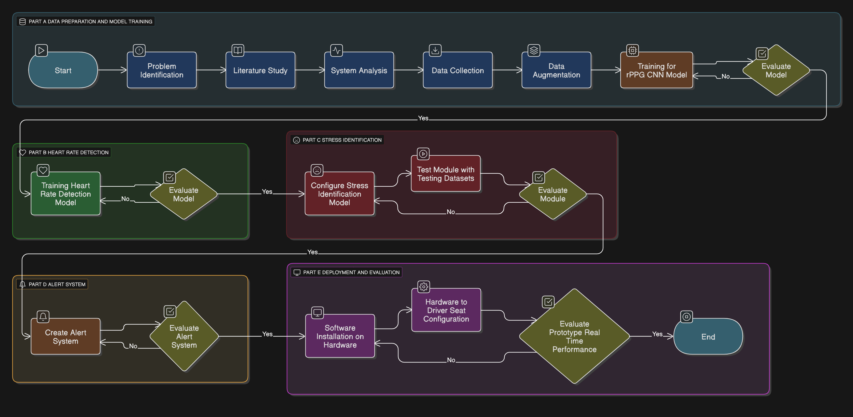
Figure 5.2.1 Project Workflow Diagram
The project workflows in Figure 5.2.1. The project begins with data preparation and model training. First, the problem is identified, followed by a literature study and system analysis to establish the foundation. Afterward, data is collected and enhanced through augmentation techniques. With these datasets prepared, the rPPG CNN model is trained and evaluated. If the results are unsatisfactory, the process cycles back to improving the training phase until acceptable performance is achieved.
The next stage focuses on heart rate detection and stress identification. A heart rate detection model is trained and evaluated, with revisions made if necessary. Once the heart rate detection system is validated, a stress identification model is configured and tested using appropriate datasets. This model undergoes evaluation, and if improvements are required, the testing process is repeated to strengthen the reliability of the stress detection mechanism.
Finally, the system transitions into alert generation and deployment. An alert system is developed and assessed for functionality, ensuring it responds correctly under defined conditions. Once validated, the software is installed onto hardware and integrated into the driver’s seat configuration. The prototype is then evaluated in real-time scenarios. If performance is insufficient, adjustments are made until the system achieves the desired outcome, marking the completion of the project.
Bo-Shen Chen will provide another option for implementing the system which integrates quantum-inspired algorithms into the rPPG system:
Step 1: Hybrid Embedding Construction
• Develop the CNN backbone to extract ROI features from video frames.
• Construct the tensor conversion layer to transform classical feature vectors into the simulated quantum state format required for the QiSA block.
Step 2: QiSA (Quantum-Inspired Self-Attention) Development
• Implement the simulated quantum layers using Python frameworks (e.g., PyTorch combined with tensor network libraries).
• Design the Quantum-Inspired Softmax function, leveraging probability amplitudes to enhance the detection of pulse wave peaks.
Step 3: Training & Knowledge Distillation
• Train the complex Qi-PhysFormer model on a high-performance server.
• Apply Knowledge Distillation: Transfer the noise-resilient features learned by the heavy quantum-inspired model to a lightweight student model optimized for edge devices.
Step 4: Edge Deployment & Optimization
• Quantize the model using TensorRT.
• Deploy the system on the NVIDIA Jetson Orin platform, integrating real-time inputs from IR/RGB cameras.
The above implementation will be conducted at the same time with the original project workflow.

Core Architecture

The system follows a hybrid pipeline:
      - Spatial Feature Extraction (CNN Backbone): A lightweight CNN (e.g., MobileNetV3) processes video frames to extract a spatial feature map, identifying the Region of Interest (ROI) on the driver's face.
      - Quantum-Inspired Temporal Encoder: The extracted features are passed to the Qi-PhysFormer encoder. Instead of standard self-attention, we utilize Quantum-Inspired Self-Attention (QiSA).

Media Pipe Face Tracking: A detector model first identifies the location of a face within the image or video frame. A subsequent model then takes the identified facial region and predicts the 3D coordinates of the 468 landmarks, creating a detailed mesh of the facial surface.
- Evaluation
  - Datasets
    - UBFC Dataset: It is a widely used public database primarily for research in remote photoplethysmography (rPPG), a non-contact method for measuring physiological signals like heart rate using facial videos.
    - Vicomtech Driver Monitoring Dataset (DMD): There is about 25TB of raw data. All recordings were grouped by sessions, each one determined by a protocol of activities, a participant, an environment and a lighting condition. In each session Body, Face and Hands camera (with RBG, Infrared and Depth).
  - Metrics
    - Detection: rppg score and heart rate.
    - Ground Truth blood oxygen level and heart rate.
    - Decision: Measure warning alerts performance by using confusion matrix to assess the false positive and false negative.
    - Latency: To estimate delays under different input resolution and hardware configurations
    - Power: To estimate average power draw of the edge device during idle, inference, and alerting.

Potential Challenges
There are several potential limitations of proposed approach:
  - Surrounding Light Impact on the rPPG detection
Normal RGB cameras are going to be heavily influenced by the environmental lighting. In bright environment and dark environment, the RGB camera will have unreliable readings for the detections. With prior experience, IR cameras can greatly reduce the influence of the bright environment. But the actual performance still needs to be tested.
  - High computational load
The model runs two tasks in parallel which could cause high computation load. To address this issue, knowledge distillation could reduce computation power by transferring knowledge learned by larger model to a smaller and efficient model. This enables the smaller model to have faster inference and deployment of less powerful hardware.
  - Lack of real time responsiveness
The proposed approach lacks real time responsiveness because of high computational load which causes latency during inference. Implementing knowledge distillation could reduce inference time.

Hypothesis
The proposed approach enhances drivers’ safety on the road with the help of the monitoring system. RPPG and heartbeat detection can help determine whether the drivers are in good driving condition. The warning system can help warn drivers whenever drivers have subpar driving conditions. Drivers will have safer road experience when using this system while driving.

Work Plan and Timeline for Shan-Wei Chang and Bo-Shen Chen
This proposed project consists of three phases:

Phase 1: Planning and Development (August 2025 - December 2025)
This initial phase focuses on laying the groundwork for the project, from research to building the core prototype.
- August - September 2025: Literature Review and Ethical Considerations. This is the foundational stage. You'll conduct a comprehensive review of existing research on driver monitoring systems. Concurrently, you should address ethical considerations, ensuring all data collection and privacy protocols are in place before any experimentation begins. Intellectual property survey for the AI driving monitoring system needs to be done.
- October - December 2025: Prototype Development and Algorithmic Design. This is where the physical and digital systems are built.
- Hardware System: Assemble the RGB camera, IR camera, Raspberry Pi, and CMS50E Pulse Oximeter.
- Algorithms and Models: Develop and fine-tune the CNN, LSTM, NN, and rPPG algorithms. This includes addressing potential bottlenecks like environmental lighting, temperature, and vehicle stability.
- October - December 2025: Experimental Design. Once the prototype is developed, you'll create a detailed experimental framework for lab-based testing. This will include defining simulated driving scenarios and methods for assessing driver fatigue
- For Bo-Shen Chen, he will conduct Algorithm Design & Simulation
  - Mathematical modeling of the Quantum-Inspired Attention mechanism.
  - Building the Qi-PhysFormer prototype in a simulation environment.
  - Collecting initial rPPG datasets for small-scale testing.

Phase 2 – Testing and Analysis (January 2026 - April 2026)
This phase involves collecting and analyzing data, both in a controlled environment and in the real world.
- January 2026: Data Collection (Lab-based). Using the prototype and the experimental design, you'll collect data from participants in a simulated environment. This will allow for initial testing and refinement of the system.
- February 2026: Multi-modal Data Analysis. You'll implement your machine learning algorithms to analyze the collected data, extracting features and classifying driver readiness. This is a critical step in proving the system's viability.
- March 2026: Field Testing. Take the system out of the lab and conduct real-world testing with a diverse group of drivers. This will provide valuable data under actual driving conditions and help you identify any unforeseen issues.
- April 2026: User Experience Assessment. Gather feedback from the field test participants. This qualitative data is crucial for understanding the system's usability and identifying areas for improvement.
- Bo-Shen will continue to work on Model Development and Edge Optimization:
  - Integrating the CNN backbone with the Quantum-Inspired layer.
  - Training the model on large datasets with varying lighting conditions.
  - Comparative analysis: QiSA vs. Classical Softmax.
  - Performing model pruning and Knowledge Distillation.
  - Porting the model to the RecTechnology company owned edge device.
  - Configuring the driving simulator for real-world tests (Day/Night/Tunnel).
  - Integrating the fatigue alert system based on physiological thresholds.

Phase 3 – Prototype Enhancement
The final phase focuses on validating your findings and preparing the project for public presentation.
- May - June 2026: Comparative Analysis and Statistical Validation. Compare your system's performance against existing technologies and use statistical methods to validate your results. This step adds credibility to your findings.
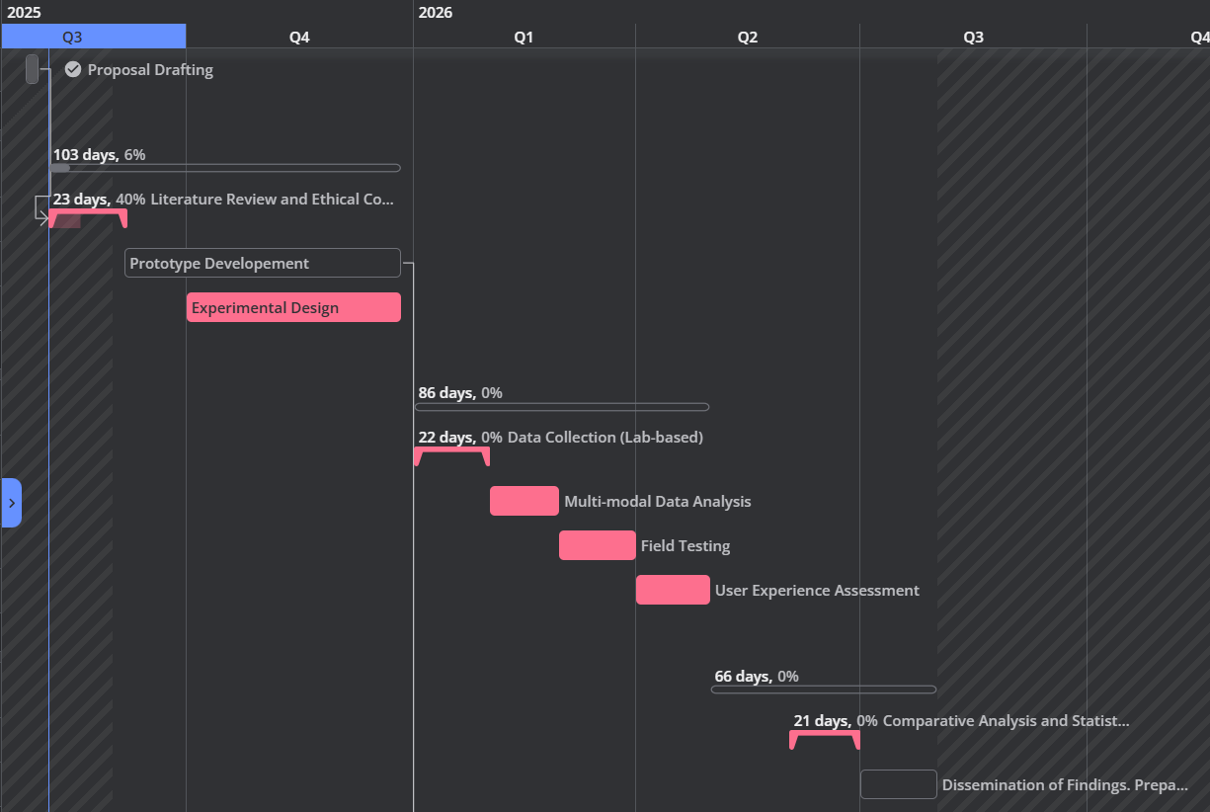
- July 2026: Dissemination of Findings. Prepare and disseminate your research findings. This includes writing academic papers, preparing for conferences, and creating presentations for stakeholders in the automotive industry. File a patent for the developed driving system.
Table 9.1 Diagram of the workplan and timeline.
Reference

B. -F. Wu, Y. -C. Wu and Y. -W. Chou, "A Compensation Network With Error Mapping for Robust Remote Photoplethysmography in Noise-Heavy Conditions," in IEEE Transactions on Instrumentation and Measurement, vol. 71, pp. 1-11, 2022, Art no. 4000211, doi: 10.1109/TIM.2022.3141149.
L. -W. Chiu, Y. -R. Chou, Y. -C. Wu and B. -F. Wu, "Deep-Learning-Based Remote Photoplethysmography Measurement in Driving Scenarios With Color and Near-Infrared Images," in IEEE Transactions on Instrumentation and Measurement, vol. 72, pp. 1-12, 2023, Art no. 5031612, doi: 10.1109/TIM.2023.3328703.
Li, Zhengzheng & Zou, Jiancheng & Yan, Peizhou & Hong, Don. (2021). Non-contact Real-time Monitoring of Driver’s Physiological Parameters under Ambient Light Condition. Intelligent Automation & Soft Computing. 28. 811-822. 10.32604/iasc.2021.016516.
Preparatory Office of Personal Data Protection Commission, "Personal Data Protection Act," Laws & Regulations Database of The Republic of China (Taiwan), Dec. 25, 2018. [Online]. Available: https://law.moj.gov.tw/ENG/LawClass/LawAll.aspx?pcode=I0050021. [Accessed: Aug. 6, 2025].
S. G. Ahmed, K. Verbert, N. Zaki, A. Khalil, H. Aljassmi, and F. Alnajjar, “AI Innovations in rPPG Systems for Driver Monitoring: Comprehensive Systematic Review and Future Prospects,” *IEEE Access*, vol. 13, pp. 22893–22918, Jan. 2025, doi: 10.1109/ACCESS.2025.3535540.
S. Park, B. -K. Kim and S. -Y. Dong, "Self-Supervised RGB-NIR Fusion Video Vision Transformer Framework for rPPG Estimation," in IEEE Transactions on Instrumentation and Measurement, vol. 71, pp. 1-10, 2022, Art no. 5024910, doi: 10.1109/TIM.2022.3217867.
Sung EJ, Min BC, Kim SC, Kim CJ. Effects of oxygen concentrations on driver fatigue during simulated driving. Appl Ergon. 2005 Jan;36(1):25-31. doi: 10.1016/j.apergo.2004.09.003. Epub 2004 Oct 31. PMID: 15627418.
Warnecke, J.M., Lasenby, J. & Deserno, T.M. Robust in-vehicle respiratory rate detection using multimodal signal fusion. Sci Rep 13, 20435 (2023). https://doi.org/10.1038/s41598-023-47504-y

